
National University of Sciences & Technology (NUST) Balochistan Campus (NBC), Department of Computer Science
Department of Computing
CS-250: Data Structure and Algorithms
Class: BSCS Fall 2024

Lab 4: Date: 9th October 2024
Time: 10:00- 13:00
Lab Engr: Safder Ali

NAME | SAMEER TALREJA
CMS | 457795

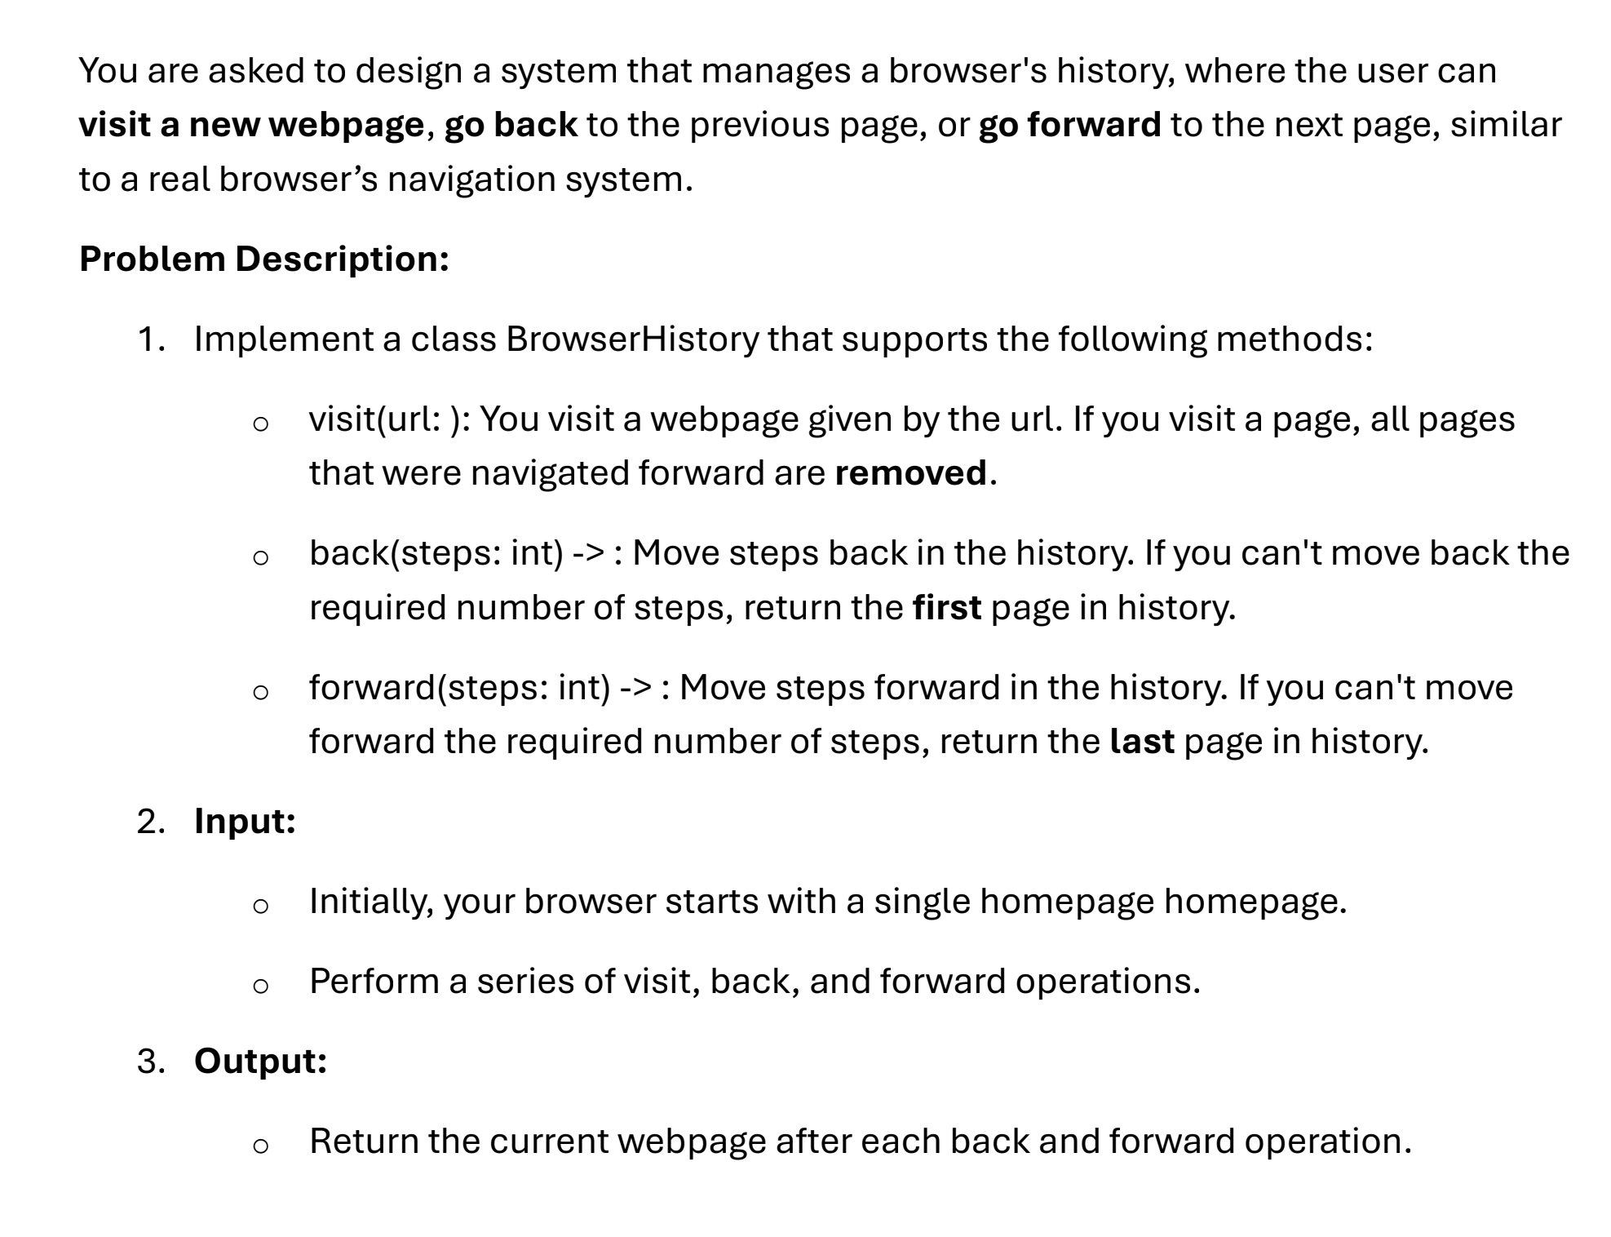
CODE:
#include <iostream>
#include <string>
using namespace std;

class node {
public:
string url;
node* next;
node* prev;

node(string homepage) {
this->url = homepage;
this->next = NULL;
this->prev = NULL;
}
};

class Browser {
public:
node* currentpage;

Browser(string homepage) {
currentpage = new node(homepage);
}

void visit(string url) {
node* temp = new node(url);
currentpage->next = temp;
temp->prev = currentpage;
currentpage = temp;
}

string back(int steps) {
while (steps > 0 && currentpage->prev != NULL) {
currentpage = currentpage->prev;
steps--;
}
return currentpage->url;
}

string forward(int steps) {
while (steps > 0 && currentpage->next != NULL) {
currentpage = currentpage->next;
steps--;
}
return currentpage->url;
}
};

int main() {

Browser browser("google.com");

browser.visit("github.com");
browser.visit("Instagram.com");
browser.visit("Linkedin.com");

cout << "Current page: " << browser.currentpage->url << endl;

cout << "After going back 2 steps: " << browser.back(2) << endl;

cout << "After going forward 1 step: " << browser.forward(1) << endl;
browser.visit("openai.com");
cout << "Current page after visiting openai.com: " << browser.currentpage->url << endl;
browser.back(6);
cout<<browser.currentpage->url<<" ";

return 0;
}

output:
